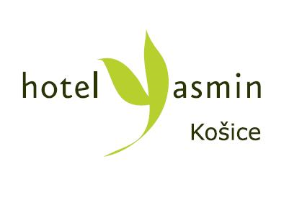

3rd NGP-NET Symposium on Non-Globular Proteins

Kindly return this form to organizing committee not later than June 21,2017
Email: ngp17@saske.sk
Phone : +421 55 72 04 132

Name:
First Name
Institution

Telephone number:

Email address:

Check-In (Date):

Check-Out (Date):

Arrival Time:

Requested Room Type:

- Superior Room (single occupancy): 86€ / night incl. breakfast

- Superior Room (double occupancy): 97€ / night incl. breakfast

All rates quoted are per room per night including breakfast, city tax and 20% VAT.

The price of accommodation includes: one-time hour entry to wellness, free parking, free room wi-fi and fitness entry.

In the case of accommodation in a double room, please notice the name of the second person in the room:…………………..

Double bed twin beds

Credit card details are required to make a booking.

CARDHOLDERS CREDIT CARD DETAILS
Cardholder´s name:
Type of credit card:
Credit Card Number:
Expiry Date:
CVC:

Accomodation will be paid at reception desk.

Cancellation policy

If cancelled up to 5 day before the date of your arrival no fee will be charged. If cancelled later or in case of no-show, the 100% of reservation will be charged.

